# HIVE MINI PROJECT -2

We have only inserted the 2017 data directly into the table as it was 2GB data and is impacting the system performance

**Part-I: Examine the data**

1. **Find the total number of tickets for the year.**

select count(distinct summons_number) No_of_Tickets ,year(issue_date) as year_of_issue from parking_violations_2017 group by year(issue_date);

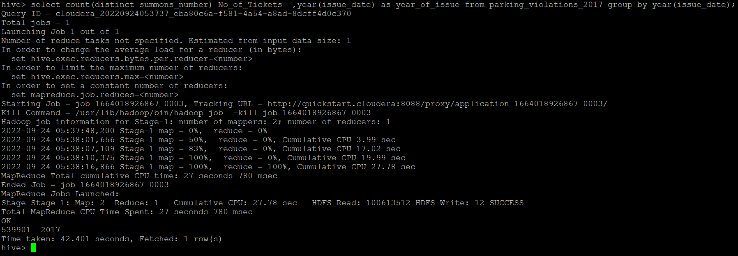

**2.) Find out how many unique states the cars which got parking tickets came from.**

select count(distinct Registration_State) as Registration_states from parking_violations_2017;

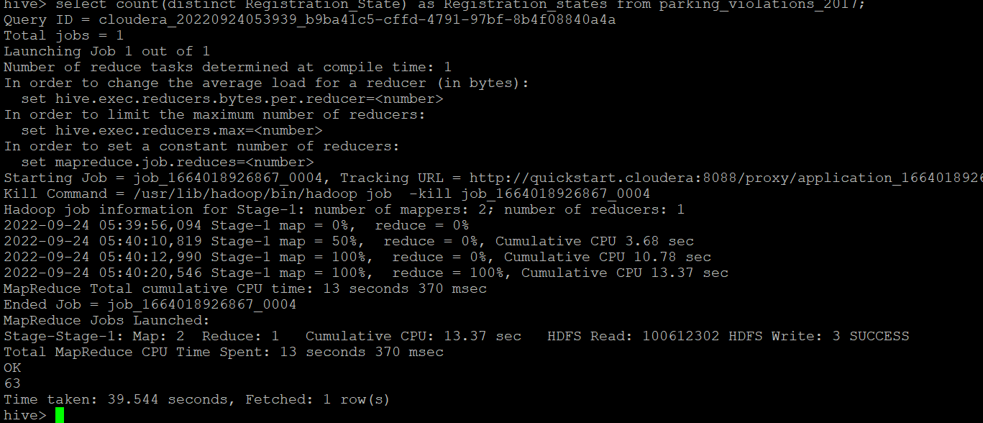

**3.) Some parking tickets don’t have addresses on them, which is cause for concern. Find out how many such tickets there are(i.e. tickets where either "Street Code 1" or "Street Code 2" or "Street Code 3" is empty )**

select count(distinct summons_number) as Tickets_without_address from parking_violations_2017 where Street_code1 = 0 or Street_code2 = 0 or Street_code3 = 0;

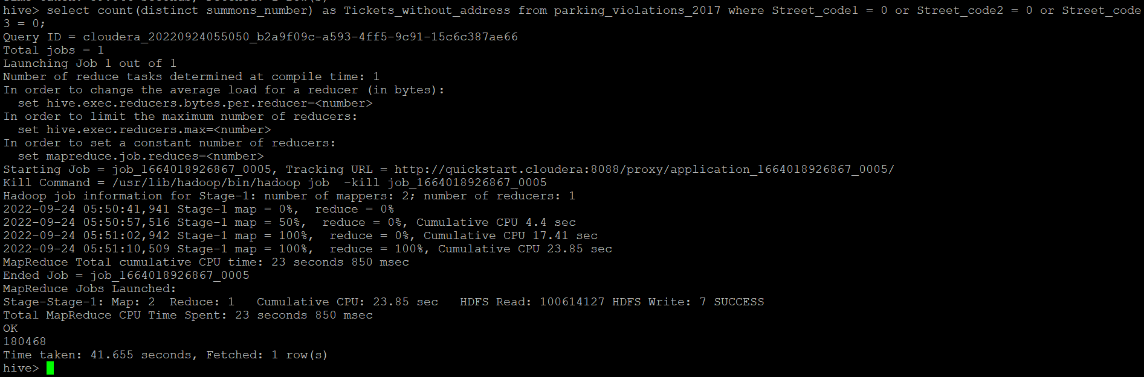

**Part-II: Aggregation tasks**

**1.) How often does each violation code occur? (frequency of violation codes - find the top 5)**

select count(Violation_Code) as frequency_of_violation_codes,Violation_Code from parking_violations_2017 group by Violation_Code order by frequency_of_violation_codes desc limit 5;

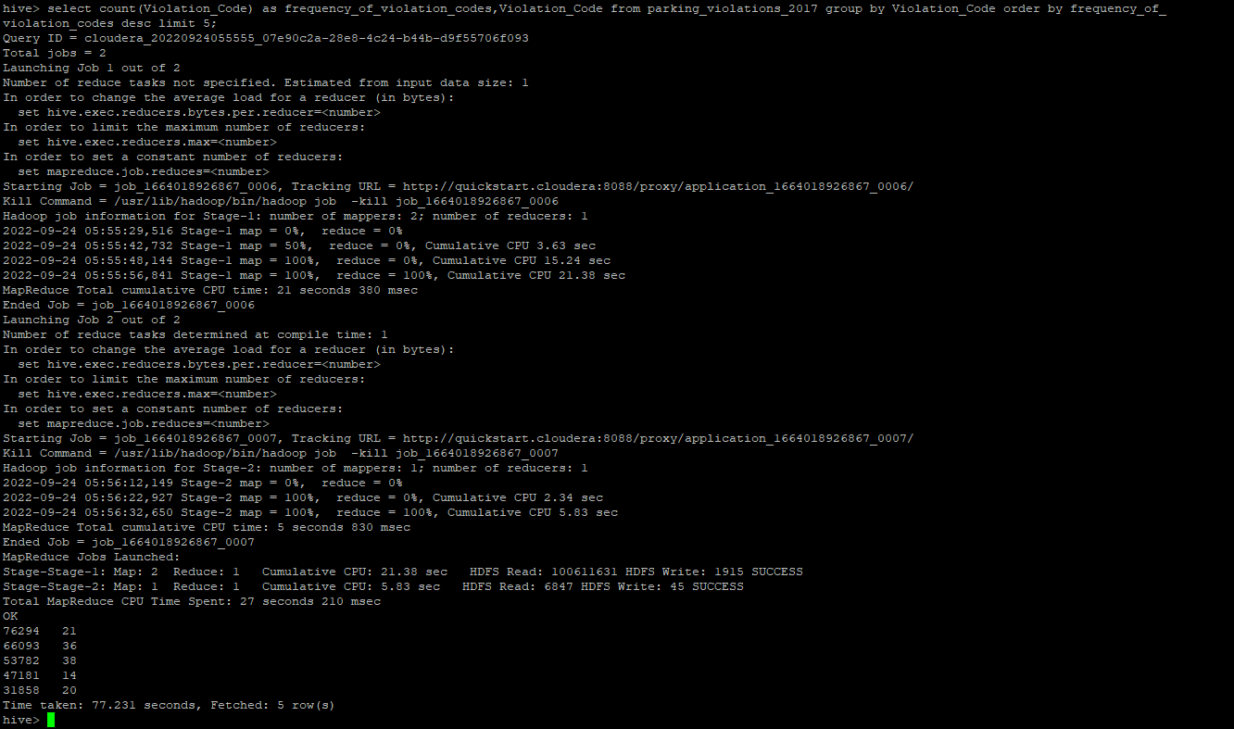

**2.) How often does each vehicle body type get a parking ticket? How about the vehicle make? (find the top 5 for both)**

select Vehicle_Body_Type,count(summons_number)as frequency_of_Vehicle_body from parking_violations_2017 group by Vehicle_Body_Type order by frequency_of_Vehicle_body desc limit 5;

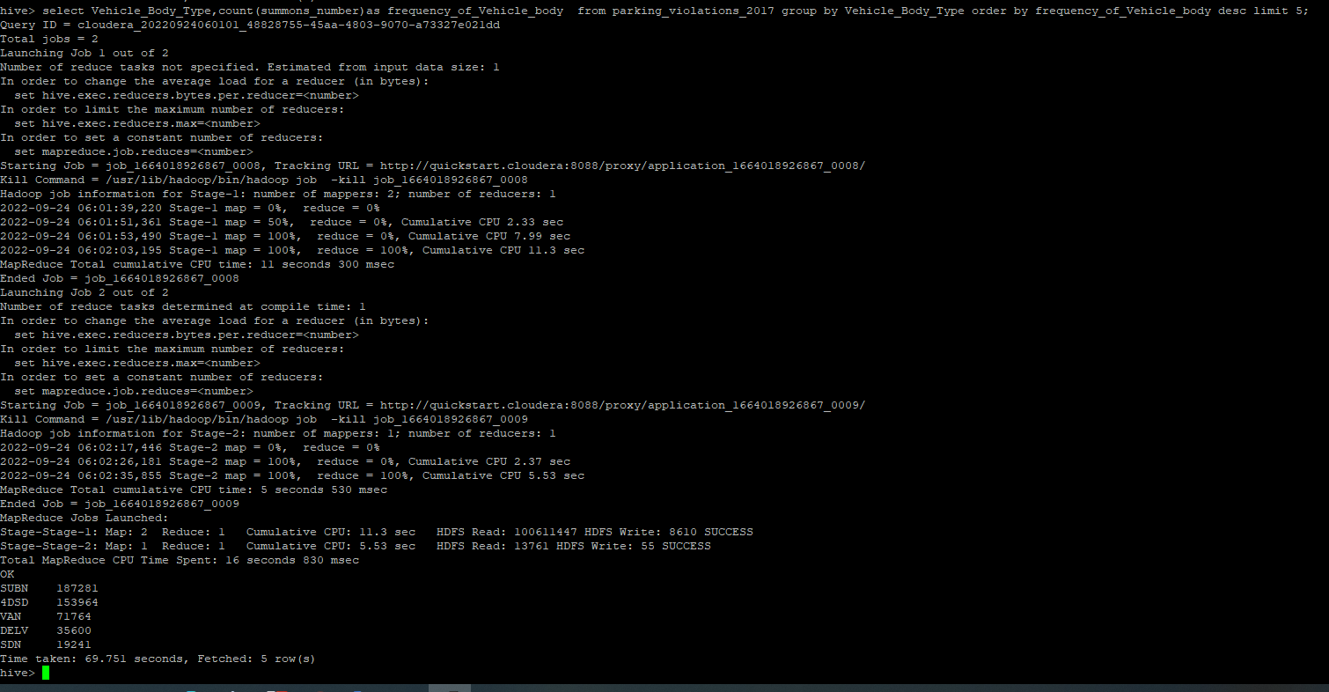

select Vehicle_make,count(summons_number)as frequency_of_vehicle_make from parking_violations_2017 group by Vehicle_make order by frequency_of_vehicle_make desc limit 5;

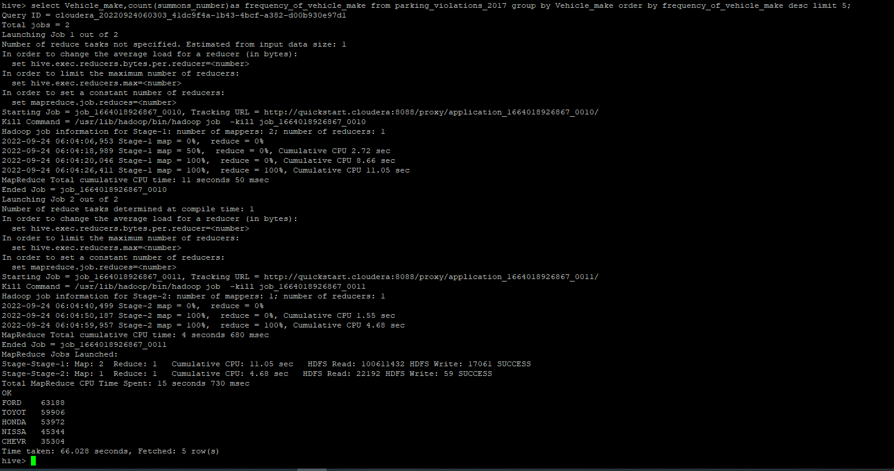

**3.) A precinct is a police station that has a certain zone of the city under its command. Find the (5 highest) frequencies of:**

**a.) Violating Precincts (this is the precinct of the zone where the violation occurred)**

select Violation_Precinct ,count(Violation_Precinct) as frequency_violation_precinct from parking_violations_2017 group by Violation_Precinct order by frequency_violation_precinct desc limit 5;

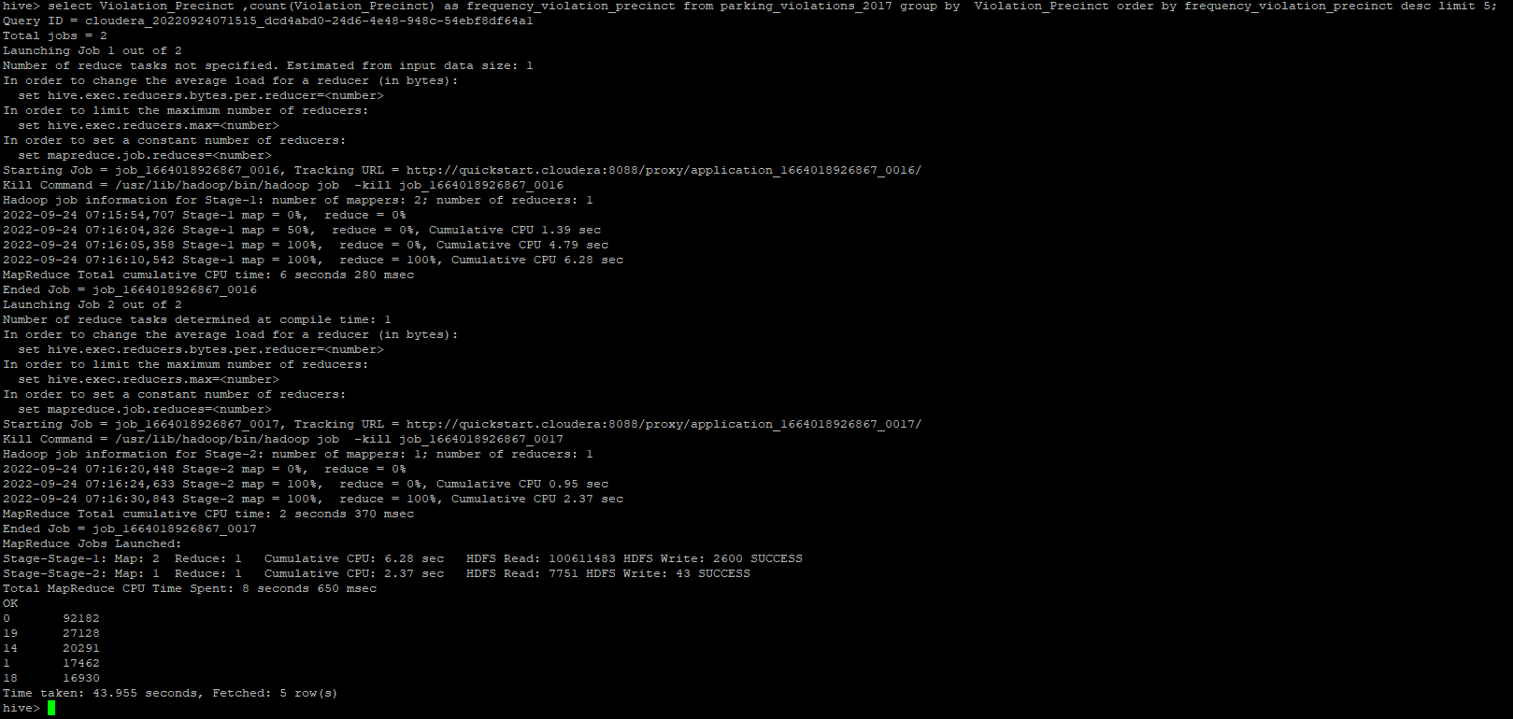 **b.) Issuer Precincts (this is the precinct that issued the ticket)**

select issuer_Precinct ,count(issuer_Precinct) as frequency_issuer_precinct from parking_violations_2017 group by issuer_Precinct order by frequency_issuer_precinct desc limit 5;

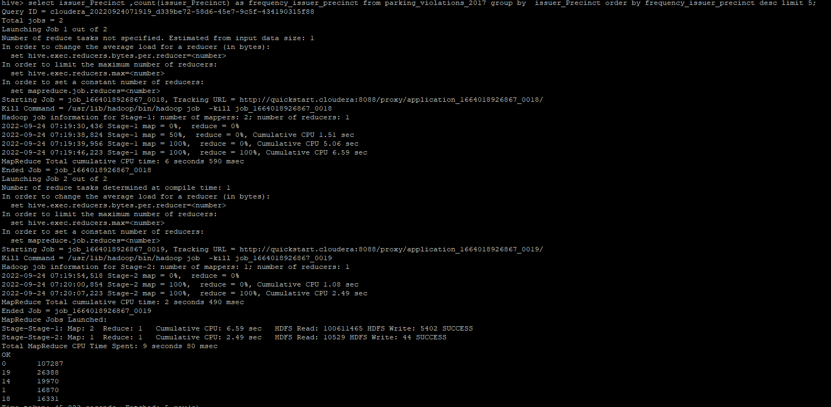

**4.) Find the violation code frequency across 3 precincts which have issued the most number of tickets - do these precinct zones have an exceptionally high frequency of certain violation codes?**

select Issuer_Precinct,Violation_Code, count(*) as Violation_code_frequency from parking_violations_2017 group by Issuer_Precinct, Violation_Code order by Violation_code_frequency desc limit 8;

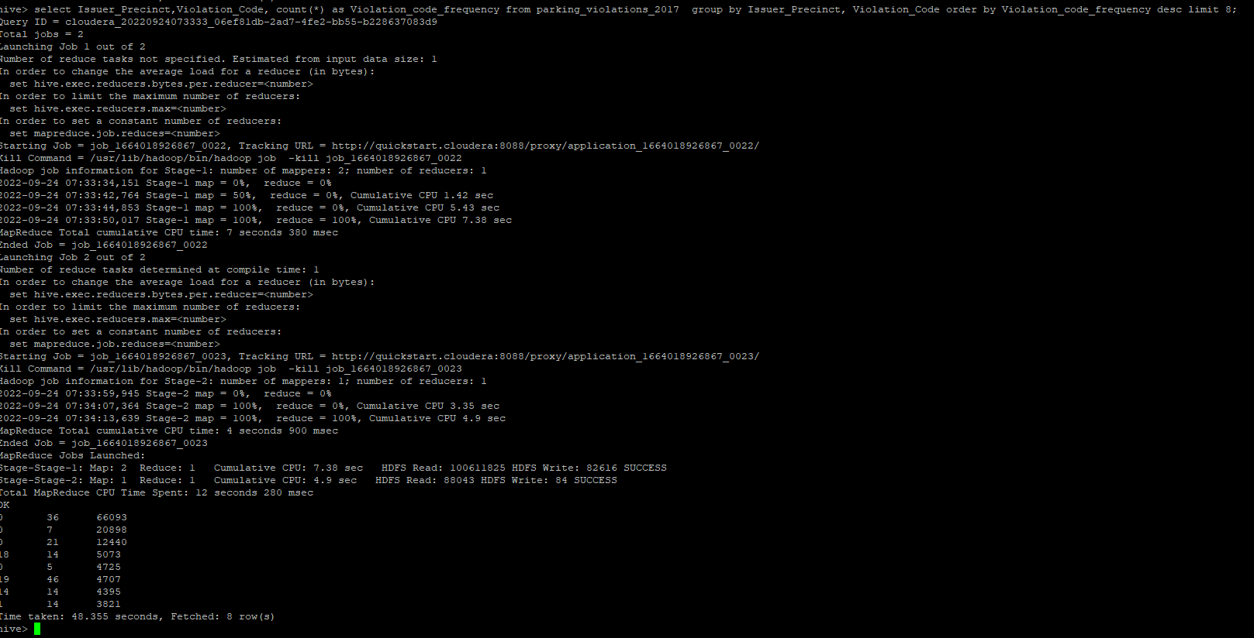

Apart from zero, 18,19,14 are the three issuer precincts which have the maximum number of violations.

Issuer Precinct 18

select Issuer_Precinct,Violation_Code, count(*) as Violation_code_frequency from parking_violations_2017 where issuer_precinct = 18 group by Issuer_Precinct, Violation_Code order by Violation_code_frequency desc limit 8;

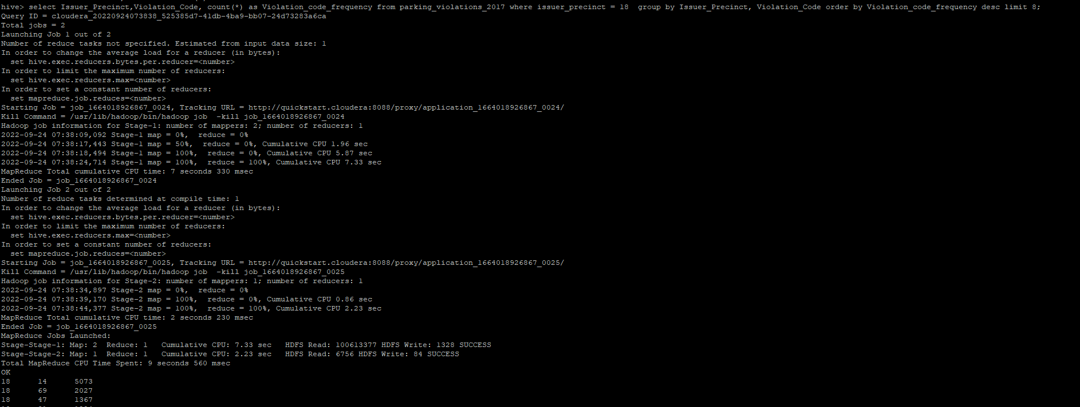

Issuer Precinct 19

select Issuer_Precinct,Violation_Code, count(*) as Violation_code_frequency from parking_violations_2017 where issuer_precinct = 19 group by Issuer_Precinct, Violation_Code order by Violation_code_frequency desc limit 8;

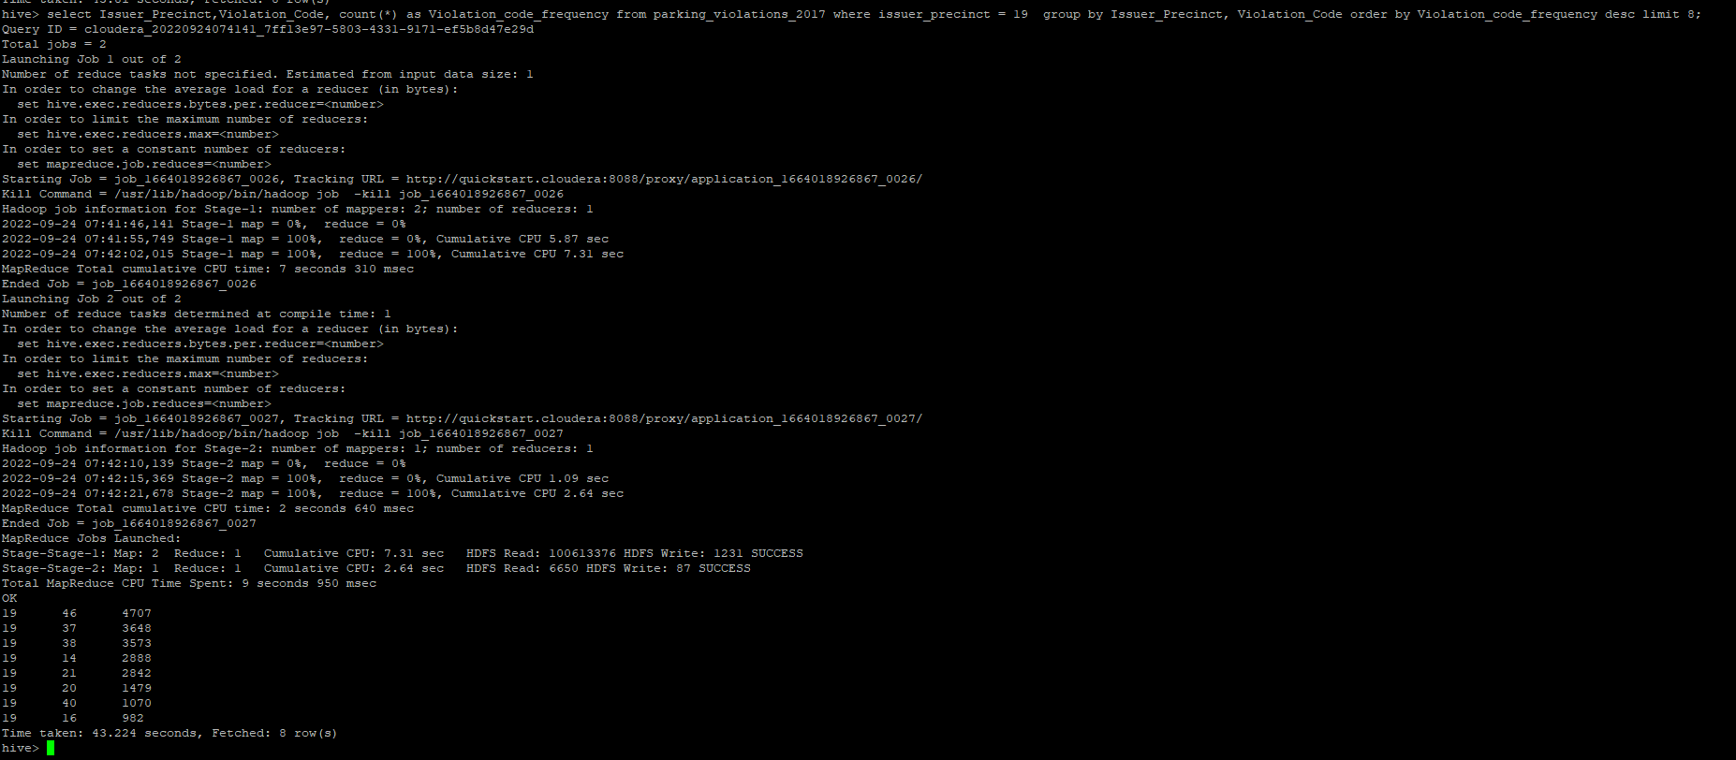

Issuer Precinct 14

select Issuer_Precinct,Violation_Code, count(*) as Violation_code_frequency from parking_violations_2017 where issuer_precinct = 14 group by Issuer_Precinct, Violation_Code order by Violation_code_frequency desc limit 8;

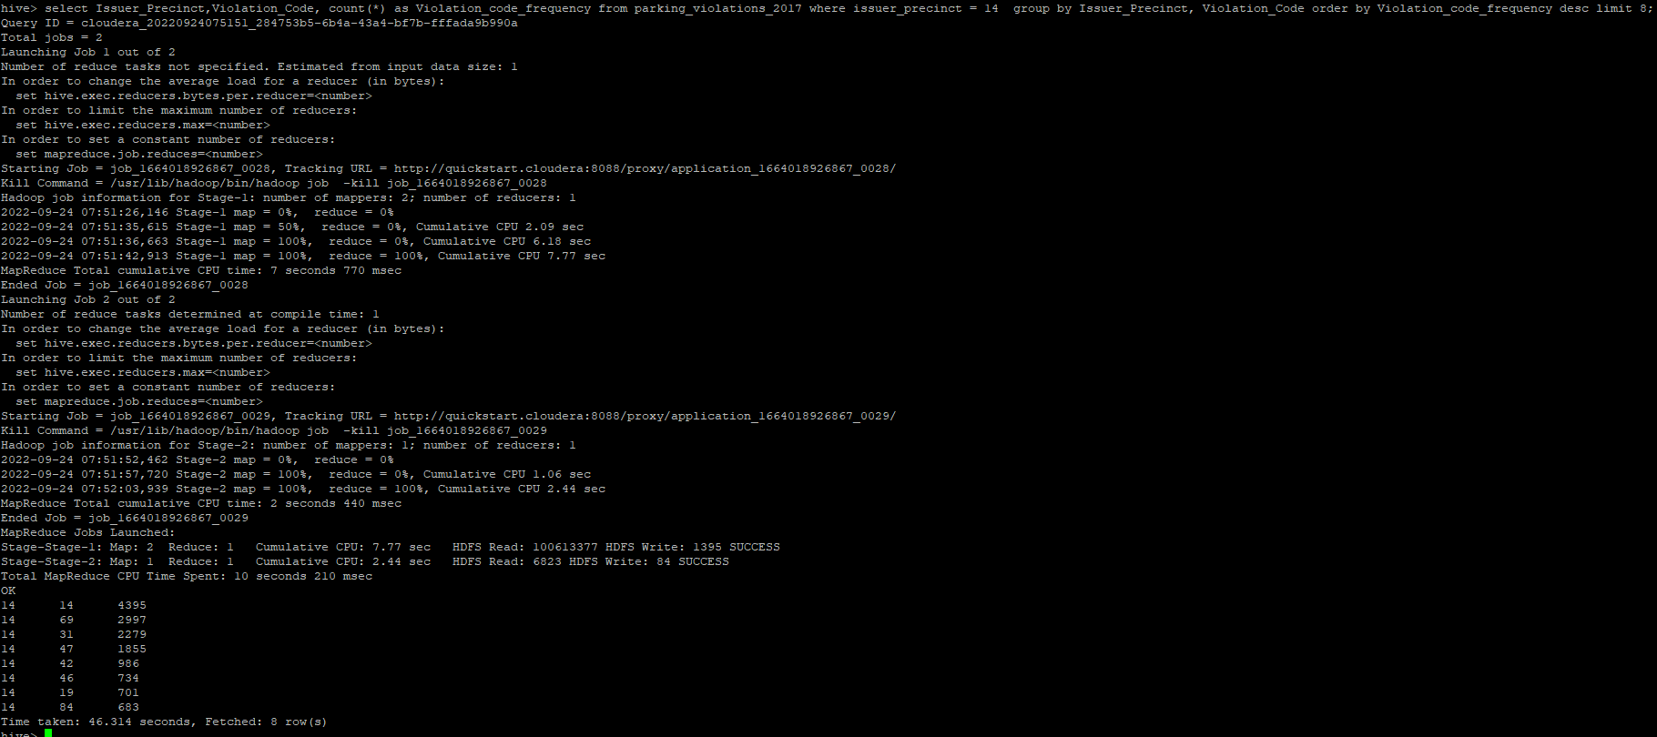

Common codes across precincts

select Issuer_Precinct,Violation_Code, count(*) as Violation_code_frequency from parking_violations_2017 where issuer_precinct in (18,19,14) group by Issuer_Precinct, Violation_Code order by Violation_code_frequency desc limit 8;

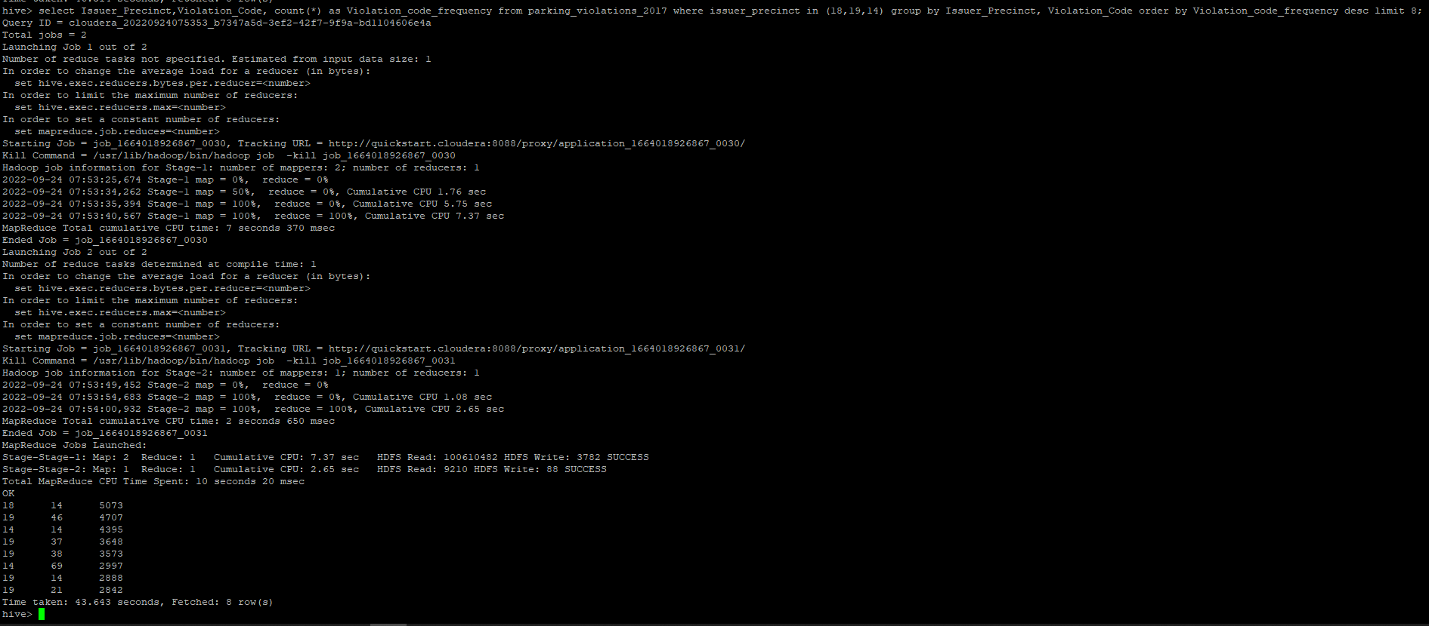

**5.) Find out the properties of parking violations across different times of the day: The Violation Time field is specified in a strange format. Find a way to make this into a time attribute that you can use to divide into groups.**

select from_unixtime(unix_timestamp(concat(violation_time,'M'), 'HHmmaaa'),"HH:mmaaa") as date_data from parking_violations_2017 limit 2;



Time format is now as 01:11AM

**6.) Divide 24 hours into 6 equal discrete bins of time. The intervals you choose are at your discretion. For each of these groups, find the 3 most commonly occurring violations**

create view vw_parking_violations_partitoned_2017

partitioned on (Violation_Code)

as

SELECT

Summons_Number,

Violation_Time,

Issuer_Precinct,

case

when substring(Violation_Time,1,2) in ('00','01','02','03','12') and upper(substring(Violation_Time,-1))='A' then 1

when substring(Violation_Time,1,2) in ('04','05','06','07') and upper(substring(Violation_Time,-1))='A' then 2

when substring(Violation_Time,1,2) in ('08','09','10','11') and upper(substring(Violation_Time,-1))='A' then 3

when substring(Violation_Time,1,2) in ('12','00','01','02','03') and upper(substring(Violation_Time,-1))='P' then 4

when substring(Violation_Time,1,2) in ('04','05','06','07') and upper(substring(Violation_Time,-1))='P' then 5

when substring(Violation_Time,1,2) in ('08','09','10','11') and upper(substring(Violation_Time,-1))='P'then 6

else null

end as Violation_Time_bin,

Violation_Code

from parking_violations_2017

where

Violation_Time is not null

or (length(Violation_Time)=5 and upper(substring(Violation_Time,-1))in ('A','P')

and substring(Violation_Time,1,2) in ('00','01','02','03','04','05','06','07', '08','09','10','11','12'));

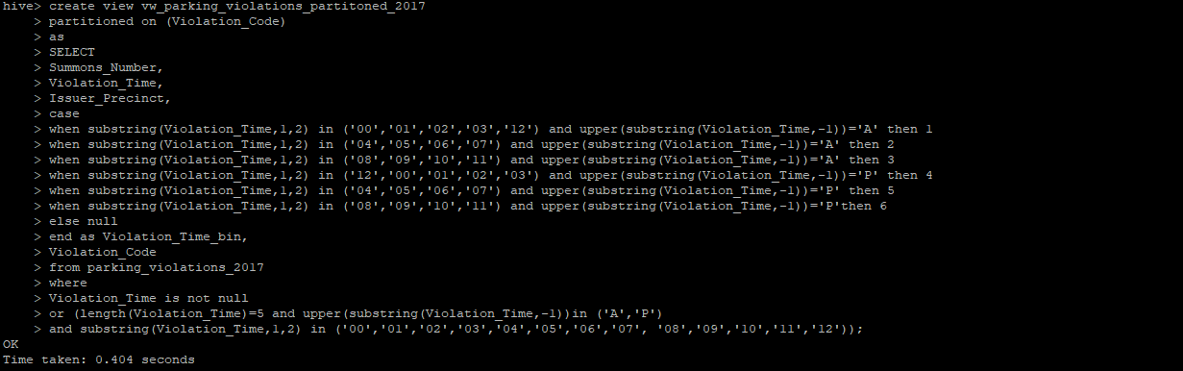

select Violation_Code,Violation_Time_bin, count(*) frequency_violation from vw_parking_violations_partitoned_2017 group by Violation_Code,Violation_Time_bin limit 5;

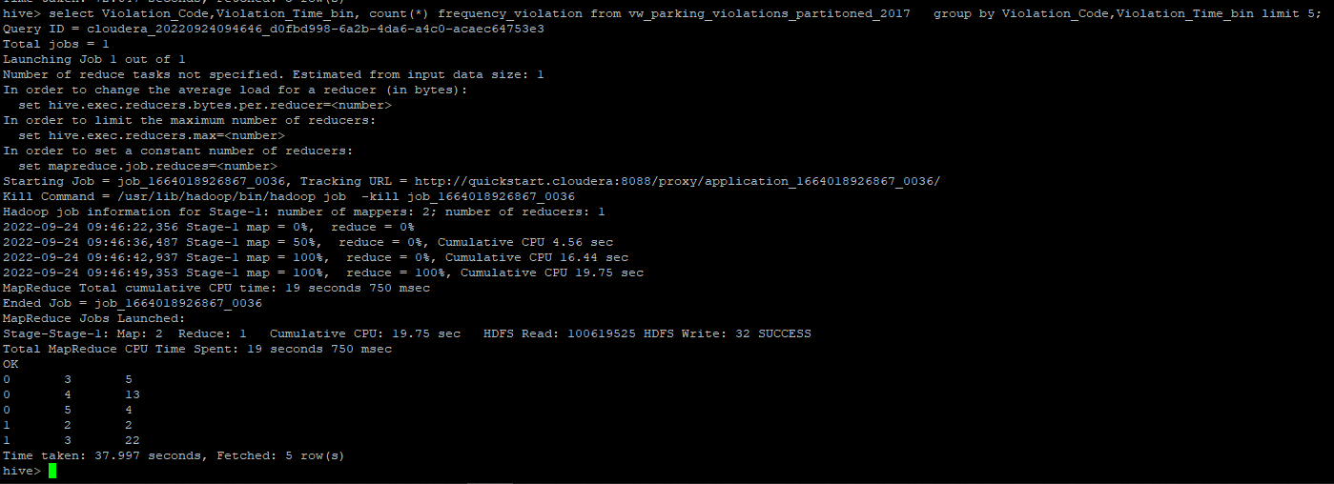

bin1

select Violation_Code,count(*) frequency_violation from vw_parking_violations_partitoned_2017 where Violation_Time_bin =1 group by Violation_Code order by frequency_violation desc limit 3;

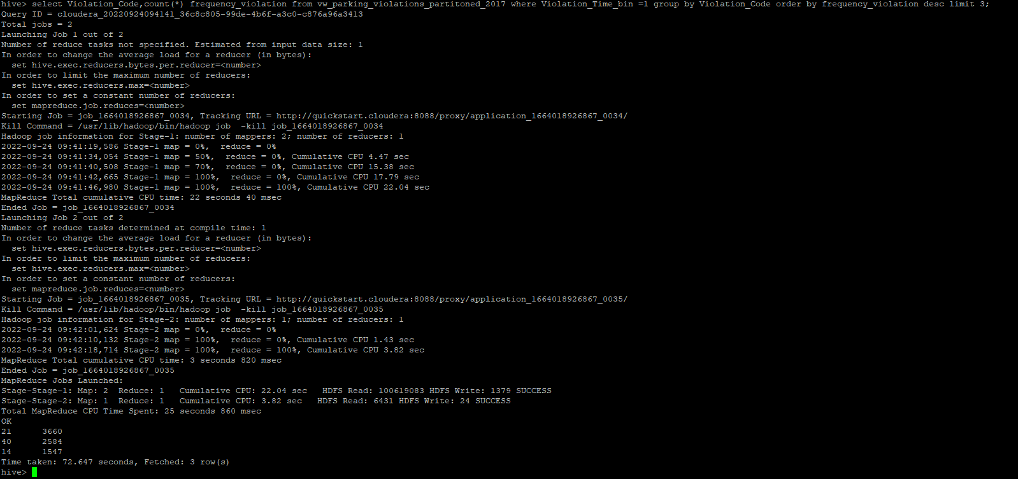

bin 2

select Violation_Code,count(*) frequency_violation from vw_parking_violations_partitoned_2017 where Violation_Time_bin =2 group by Violation_Code order by frequency_violation desc limit 3;

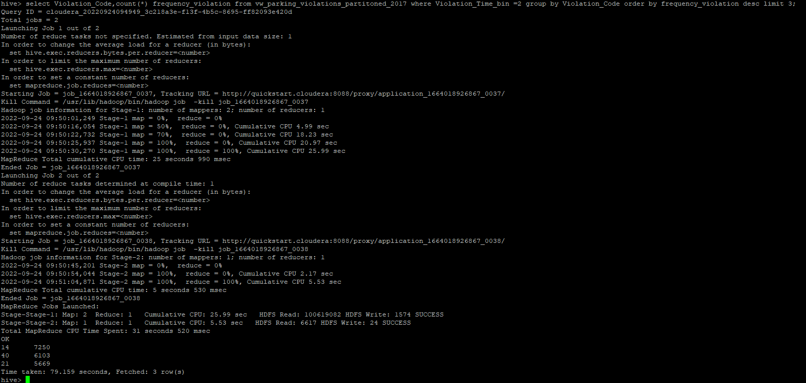

bin 3

select Violation_Code,count(*) frequency_violation from vw_parking_violations_partitoned_2017 where Violation_Time_bin =3 group by Violation_Code order by frequency_violation desc limit 3;

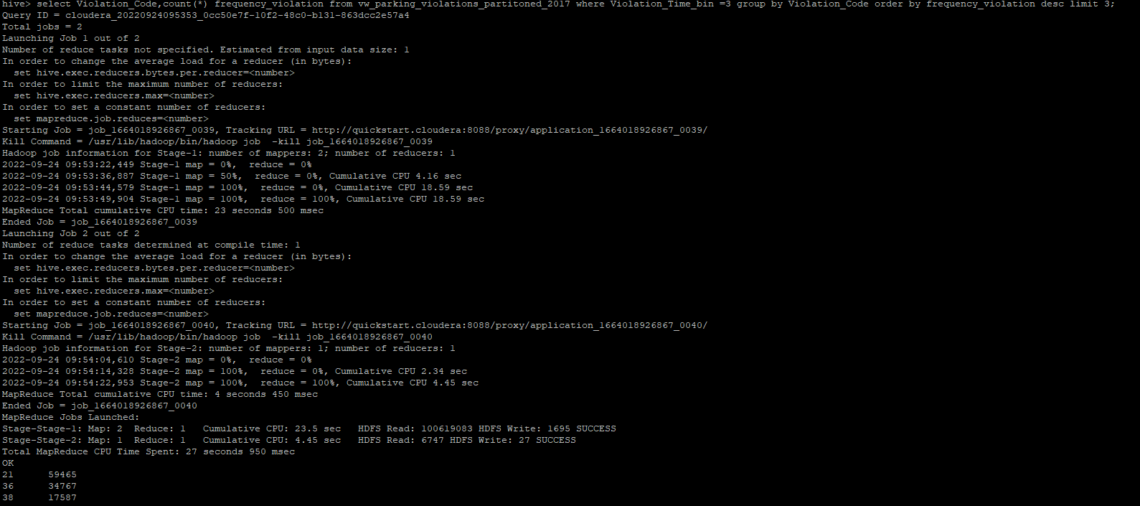

bin 4

select Violation_Code,count(*) frequency_violation from vw_parking_violations_partitoned_2017 where Violation_Time_bin =4 group by Violation_Code order by frequency_violation desc limit 3;

bin 5

select Violation_Code,count(*) frequency_violation from vw_parking_violations_partitoned_2017 where Violation_Time_bin =5 group by Violation_Code order by frequency_violation desc limit 3;

bin 6

select Violation_Code,count(*) frequency_violation from vw_parking_violations_partitoned_2017 where Violation_Time_bin =6 group by Violation_Code order by frequency_violation desc limit 3;

**7.) Now, try another direction. For the 3 most commonly occurring violation codes, find the most common times of day (in terms of the bins from the previous part)**

select Violation_Time_bin, count(*) frequency_times from vw_parking_violations_partitoned_2017 where Violation_Code in (21, 38,36)

group by Violation_Time_bin order by frequency_times desc limit 3;

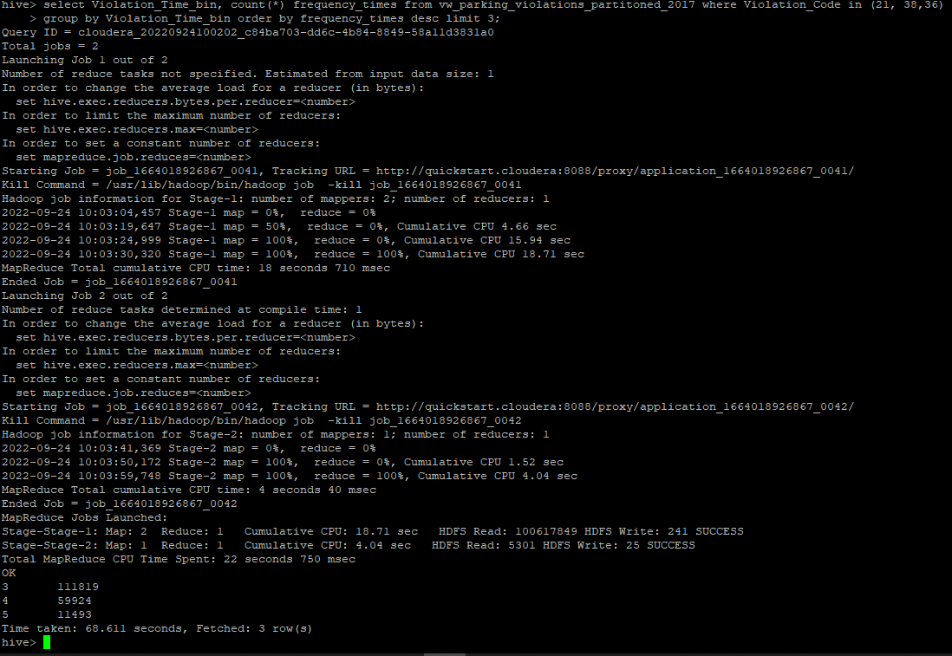

**8.) Let’s try and find some seasonality in this data**

**a.) First, divide the year into some number of seasons, and find frequencies of tickets for each season. (Hint: A quick Google search reveals the following seasons in NYC: Spring(March, April, March); Summer(June, July, August); Fall(September, October, November); Winter(December, January, February))**

create view vw_tickets_issued_2017

partitioned on (Violation_Code)

as

select Issuer_Precinct,

case

when MONTH(Issue_Date) between 03 and 05 then 'spring'

when MONTH(Issue_Date) between 06 and 08 then 'summer'

when MONTH(Issue_Date) between 09 and 11 then 'autumn'

when MONTH(Issue_Date) in (1,2,12) then 'winter'

else 'unknown'

end as season,

Violation_Code

from parking_violations_2017;

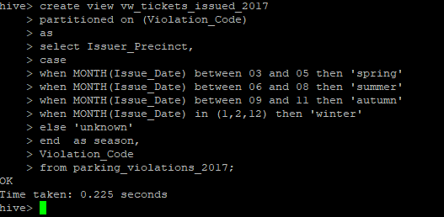

select season, count(*) as frequency from vw_tickets_issued_2017 group by season order by frequency desc;

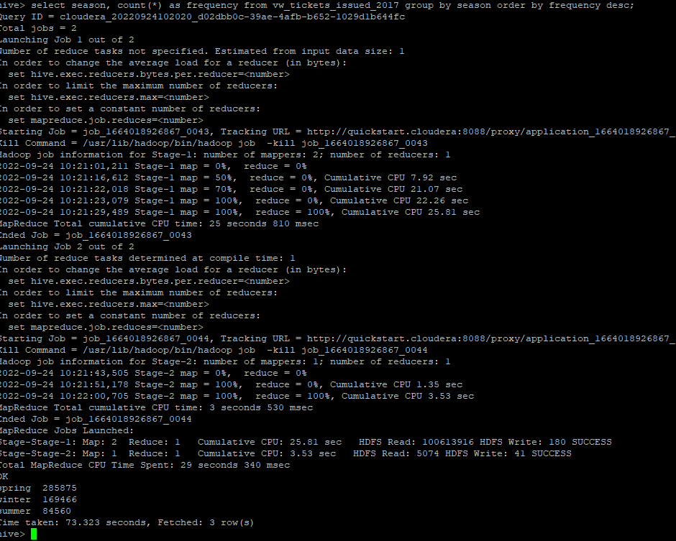

**b.)Then, find the 3 most common violations for each of these seasons.**

spring season

select Violation_Code, count(*) as frequency from vw_tickets_issued_2017 where

season = 'spring' group by Violation_Code order by frequency desc limit 3;

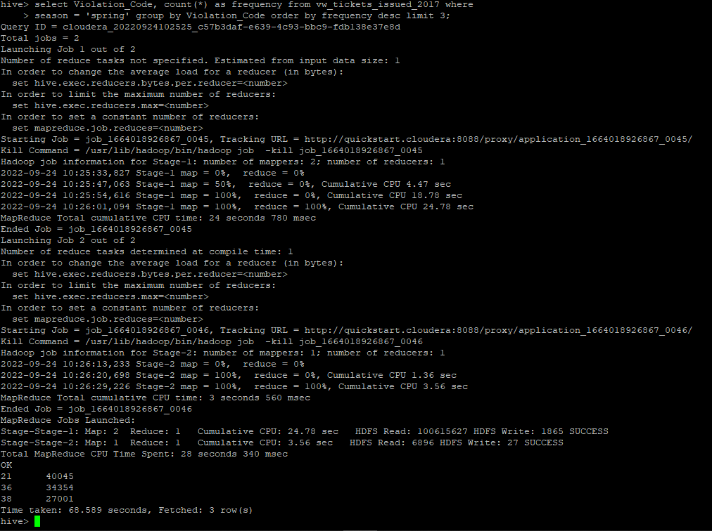

winter season

select Violation_Code, count(*) as frequency from vw_tickets_issued_2017 where

season = 'winter' group by Violation_Code order by frequency desc limit 3;

summer season

select Violation_Code, count(*) as frequency from vw_tickets_issued_2017 where

season = 'summer' group by Violation_Code order by frequency desc limit 3;

autumn season

select Violation_Code, count(*) as frequency from vw_tickets_issued_2017 where

season = 'autumn' group by Violation_Code order by frequency desc limit 3;

